Last Chancers
The Last Chancers are a special unit made up of Penal Legion convicts. They are hand-picked by Colonel Schaeffer, and are used to carry out especially dangerous (some would say suicidally dangerous!) missions. They must be used exactly as described below and may not be given extra equipment or wargear. In addition they may only be used in a battle where both players have agreed beforehand to allow the use of special characters.
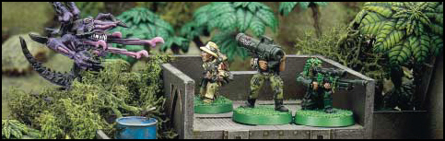
COLONEL SCHAEFFER'S LAST CHANCERS
 | Points | WS | BS | S | T | W | I | A | Ld | Sv
Colonel Schaeffer | 291 | 4 | 4 | 3 | 4 | 3 | 4 | 3 | 9 | 4+
Last Chancer | - | 3 | 4 | 3 | 3 | 1 | 3 | 1 | 8 | 5+
Squad: The squad consists of Colonel Schaeffer and eleven Last Chancers. Their equipment is described over the page.
Weapons: All models are assumed to have a laspistol, frag and krak grenades as well as the equipment listed over the page.
Options: The squad may be mounted in a Chimera. See the Chimera army list entry in the Imperial Guard Codex for points cost and details.
UNIT SPECIAL RULES
The Last Chancers can be used in one of two ways:
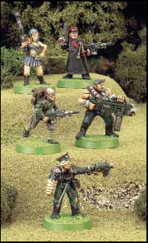
Hardened Veterans: You can use Colonel Schaeffer and the Last Chancers as the Hardened Veteran squad you are allowed to use in the army. If you decide to do this they count as one of your Elites choices. All of their equipment is described below. In addition the squad has two Battle Honours, which will always be Hardened Fighters and Steadfast (for details see page 163 in the Warhammer 40,000 rulebook). However, when used as a Hardened Veteran unit, with the exception of the rules for Colonel Schaeffer and Ox, the Individual Special Rules described below are not used. Such is Schaeffer's reputation for dealing with malingerers that, as long as the Colonel is alive, the entire squad will automatically pass any Morale or Pinning tests.
Suicide Force: Alternatively you can use Colonel Schaeffer and the Last Chancers to fight a battle on their own. If you do this then the Individual Special Rules are used. If you decide to use this option then they will always be the attackers (even against Dark Eldar!), and the Last Chancers player is allowed to pick the mission that will be played. You always use all of the Last Chancers in such a mission, and must ignore any scenario instructions that require the attacker to leave models in reserve, or that require models to be left out of the game. When used as a Suicide Force any of the the Last Chancers may infiltrate as long as the scenario allows the Infiltration rules to be used. Remember that the points value originally set for the game is still used by the opposing force, and is not reduced to match the points value of the Last Chancers; for example, if you'd agreed to play a 1,000 point game and opted to use the Last Chancers on their own then your opponent would still field a 1,000 point army (these guys aren't called the Last Chancers for nothing you know!). As a Suicide Force, each member of the unit is treated as an independent character, but will still automatically pass Morale or Pinning tests while the Colonel is still alive.
COLONEL
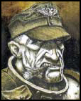
PROFILE: Tough, hard-bitten and strict. Will get the job done no matter what the cost.
WARGEAR: Plasma pistol, master crafted power weapon and carapace armour (stat line already modified).
SPECIAL RULES: Schaeffer is a master of close combat. Opponents must subtract -1 from their dice rolls to hit him.
HERO
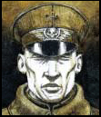
PROFILE: Outstanding officer, top of his class and with a first-class record.
CRIME: Refused a direct order to lead his men on a pointless and suicidal attack.
WARGEAR: Lasgun, laspistol and close combat weapon.
SPECIAL RULES: Hero just doesn't know when to give up. If he is killed he does not die immediately. By an effort of sheer will he stays alive, and then expires at the end of the next Last Chancers player turn. He may not be harmed during this time, and will ignore any Morale or Pinning tests, even if Colonel Schaeffer is dead.
OX
(penal COLONY–GAREVO VI–3H60AR6704D1–396859–S)
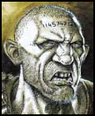
PROFILE: A huge ox of a man, and about as bright.
CRIME: Killing three off-duty officers with his bare hands in a drunken brawl.
WARGEAR: Heavy bolter.
SPECIAL RULES: Ox can move and fire with the heavy bolter. He carries his own ammunition and doesn't have a loader.
BRAINS
(penal colony–..unknown data corruption..–4HA6C8KE45R5–275974–T)
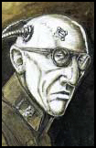
PROFILE: An expert on many forms of technology and all round brain-box. Ox and he are good buddies.
CRIME: Hacking into the Regimental accounts system and changing his pay-code.
WARGEAR: Lasgun, comm-link.
SPECIAL RULES: If Brains is killed then Ox will go berserk, doubling his Strength and Toughness for the rest of the game, and will always charge if in charge range of the enemy.
DEMOLITION MAN
(penal colony–Raels World–J59683OH59N3–916832–C)
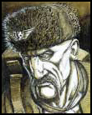
PROFILE: An expert with explosives, and capable of picking any lock and disabling any security system.
CRIME: Caught while breaking into a Colonel's personal drinks cabinet.
WARGEAR: Lasgun, melta bombs & one demolition charge.
SPECIAL RULES: A model armed with a demolition charge may use it in the shooting phase instead of making a normal shooting attack. Demolition charges are one-shot weapons with a range of 6". The attack is treated in all ways as an ordnance attack, except that the model throwing the demolition charge is allowed to move in the same turn. Place the large Ordnance template as you would normally, and then roll to see if it scatters.
Weapon | Range | Str | AP | Notes
Demolition Charge | 6" | 8 | 2 | Ordnance,  may move and fire,  one shot.
SHIV
(penal colony–temporary custody only–385923674971–960760–H)
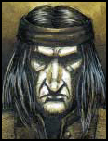
PROFILE: A stealthy assassin who can sneak up and dispatch a sentry without being spotted.
CRIME: Serial murder of over twenty civilians on Lector Prime over a five year period.
WARGEAR: Plasma pistol, mono-filament knife (counts as a power weapon).
SPECIAL RULES: Shiv will only be spotted by a sentry or allow an opponent he attacks in close combat to raise the alarm if they first roll a 6 on a D6. On a roll of 1-5 the alarm is not raised. Shiv doubles his Initiative against sentries.
GREASE MONKEY
(penal colony–devlan 5/forhith Vi–TH6E94GAD943–296686–N)
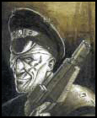
PROFILE: Expert mechanic reputed to be able to maintain, drive and repair any Imperial vehicle in the galaxy.
CRIME: Stealing the Eldar grav-vehicle belonging to the Ambassador of Iyanden Craftworld.
WARGEAR: Bolt pistol.
SPECIAL RULES: If the Last Chancers have a Chimera then Grease Monkey will drive it. He may reroll any failed Dangerous Terrain tests. If the vehicle is destroyed roll to see if he survives as if he were a passenger. In special scenarios of your own devising he can repair or hot-wire and drive any vehicle on a roll of 2+.
SCOPE
(penal colony–darson IIX–4S89NIP93ER8–571146–A)
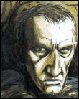
PROFILE: A trained sniper and expert marksman.
CRIME: Went AWOL, reason unconfirmed, but suspected to be related to the assassination of Chief Arbitrator Abraxtes.
WARGEAR: Needle sniper rifle.
SPECIAL RULES: Scope may choose which enemy model he shoots at, the normal targeting rules don't apply and you may choose to pick out any model including a character in a unit or a heavy weapon trooper that is in his line of sight.
ROCKET GIRL
(penal colony–barbarellus 4–B59AB45E50JL–270804–C)
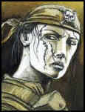
PROFILE: Master-At-Arms who is proficient with any and all of the heavy weapons employed by the Imperial Guard.
CRIME: Murdering a fellow mastersergeant for unknown reasons.
WARGEAR: Missile Launcher.
SPECIAL RULES: Years of experience means that Rocket Girl just about always places the missiles she fires in exactly the right spot. To represent this she may re-roll any Armour Penetration rolls she makes.
FINGERS
(penal colony–c’gataw penitentiary–3SCROU4NGE7R–970075–E)
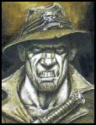
PROFILE: An expert forager and petty thief who can get hold of just about anything for a price.
CRIME: Black Marketeering.
WARGEAR: Lasgun, missiles.
SPECIAL RULES: Fingers is the loader for Rocket Girl's missile launcher, and must attempt to stay within 2" of her at all times. He's usually able to lay his hands on one or two special or experimental missiles, and to represent this, as long as Fingers is alive, once per battle Rocket Girl may make a special missile attack at +D3 Strength (up to a maximum of Strength 10).
ANIMAL
“records restricted to level 14 access only”
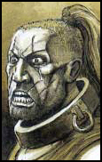
PROFILE: A schizophrenic psychopath, but reputed to be one of the best all round warriors in the Imperial Guard.
CRIME: See sub-file 84 beta, sections 103 to 196.
WARGEAR: Meltagun, scanner, close combat weapon.
SPECIAL RULES: Animal has lightning fast reactions which provide him with a 4+ invulnerable save, and which doubles his Initiative and gives him +1 attack in close combat.
WARRIOR WOMAN
(penal Colony–tophawr III–see attached file–3482XEN75A15–185027–S)
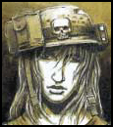
PROFILE: One of the renowned warriorwomen of Xenan 7, an expert tracker and huntswoman.
CRIME: Membership of a banned organisation (ref; Artemis subcult).
WARGEAR: Lasgun, sword and knife (counts as two close combat weapons).
SPECIAL RULES: Warrior Woman adds +1 to any cover saves. In addition when she charges she may leap into combat. This adds D3" to her charge move and doubles her charging attack bonus from +1 to +2.

